Parent PLUS Loan
To Do List Guidance

Check the student’s To Do List in My Akron’s Student Center to see which item(s) are outstanding.
If Parent PLUS Master Promissory Note (MPN)–MPN for Parent is needed:
- Go to www.studentaid.gov and select “Parent”
- Click on Complete A Master Promissory Note (MPN) for a Parent PLUS Loan.
- Log in with Parent FSA ID and complete the Parent Master Promissory Note.

If PLUS Credit Counseling is needed:
- Go to www.studentaid.gov and select “Parent”
- Click on Complete PLUS Credit Counseling. This step is required if you have been denied a PLUS Loan and obtained an Endorser (Co-signer). The Endorser will need to log in and complete the Endorser Addendum to approve the loan amount. FSA ID
- Log in with your (Parent FSA ID) (Don’t use the student’s ID and password). As the loan is in your name based on your credit.

If the Annual Student Loan Acknowledgment is needed:
This federal requirement is new and must be completed every year beginning in
the 2021-2022 Academic Aid year.

- Go to www.studentaid.gov and select “Parent
- Click on Complete the Annual Student Loan Acknowledgment.
- Log in with your (Parent FSA ID)

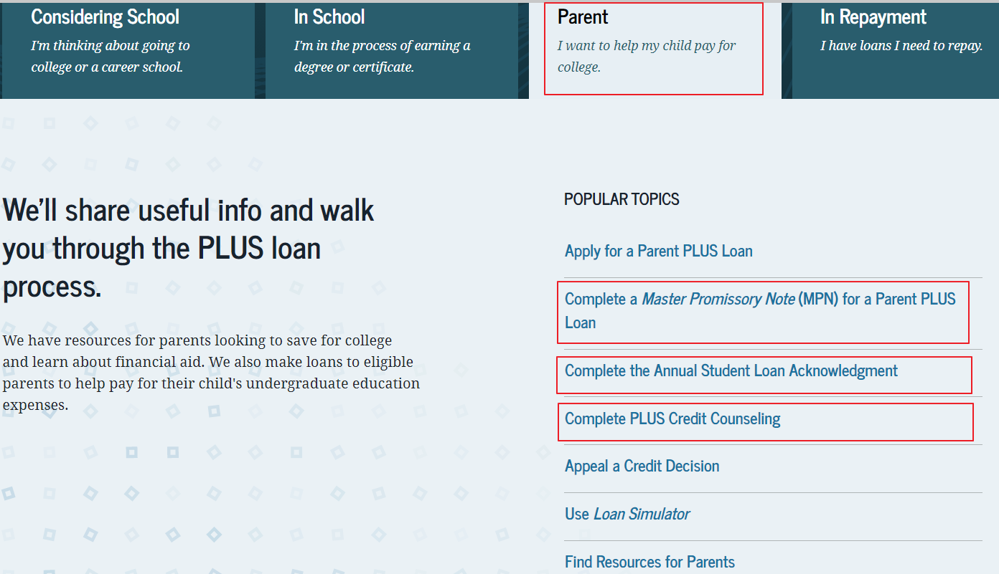
The University of Akron will receive notification when you complete the outstanding requirement(s). Please allow 5 business days for the To Do List to be updated.

